Post Graduate Department of Sanskrit
DETAILS OF THE SEMINARS/WORKSHOPS FROM JUNE 2017

Vanamali Multi Disciplinary Lecture Series (from June 2017)

Lecture VI - 19/09/2017
Resource Person - Dr. E. Vinitha, Asst. Professor of Sanskrit, Christ College, Irinjalakuda
Topic - Critical Evaluation of Kalidasa's Meghasandesa

Lecture VII and Book Release
17/10/2017
Book Name : The Traditional Art – Raptures and Ruptures
Edited By Dr. Lakshmi Sankar, Asst.Professor and Head, Department of Sanskrit, Sree Krishna College, Guruvayur.
Released By Dr.Ettumanoor P Kannan , Directoer,Sangeethanadaka Acadamy, Koodiyattakendra.
Received By – Sri. Radhakrishnan Kakkassery, Rtd. Teacher and Renowned Poet
Key note address - Dr. T.N.Vasudevan, HoD of Physics, University of Calicut
Topic - Appreciation of Kerala Performing Arts and Innovations in Krishnanattom Performance
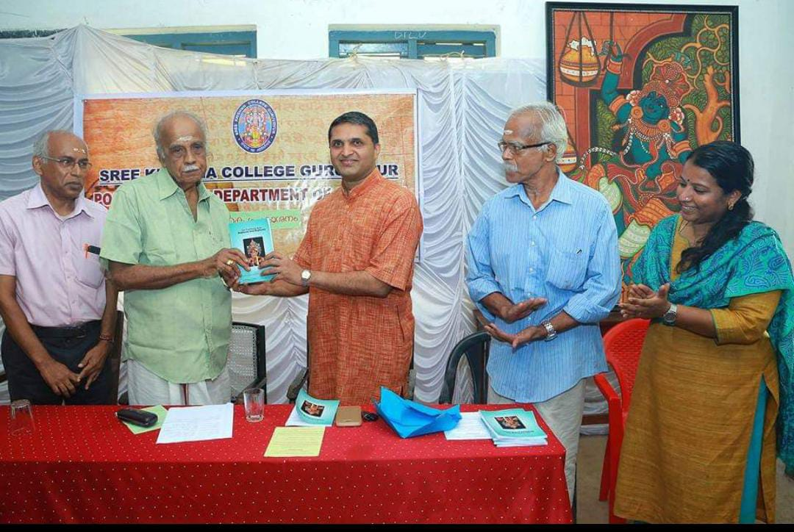
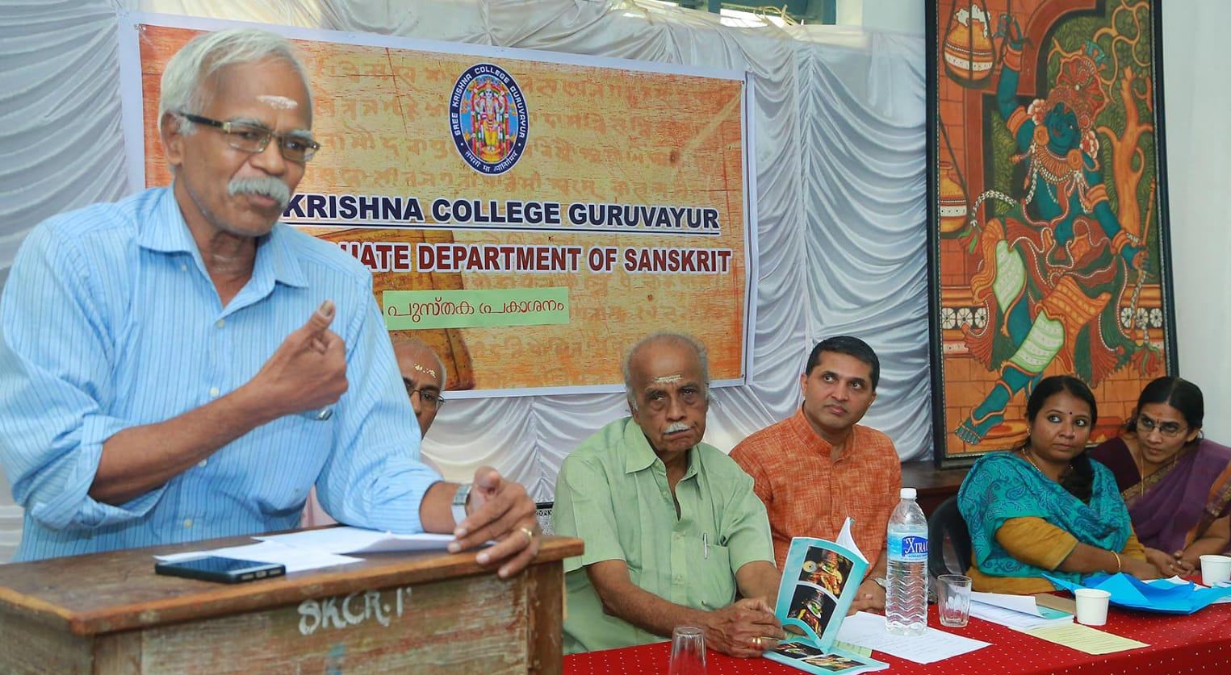
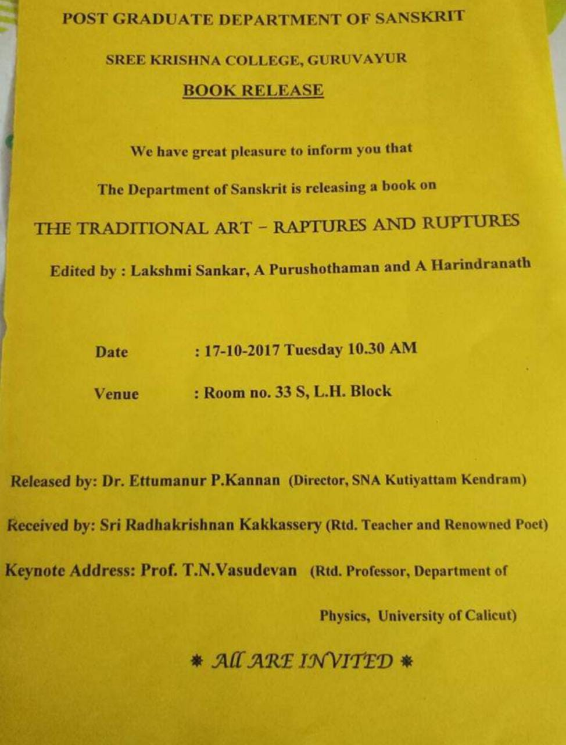

Lecture VIII
05/01/2018
Resource Person - Dr. Rustom Bharucha, Professor of Theatre and Performance Studies, JNU.
Topic - Studying Performance Traditions - Challenges and Possibilities
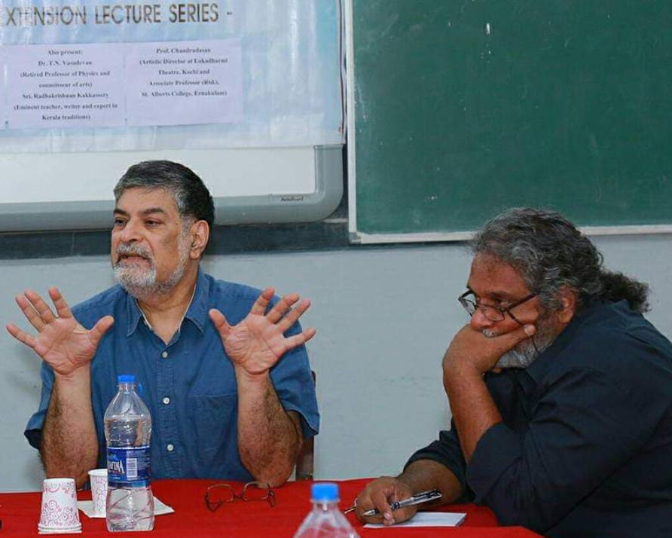
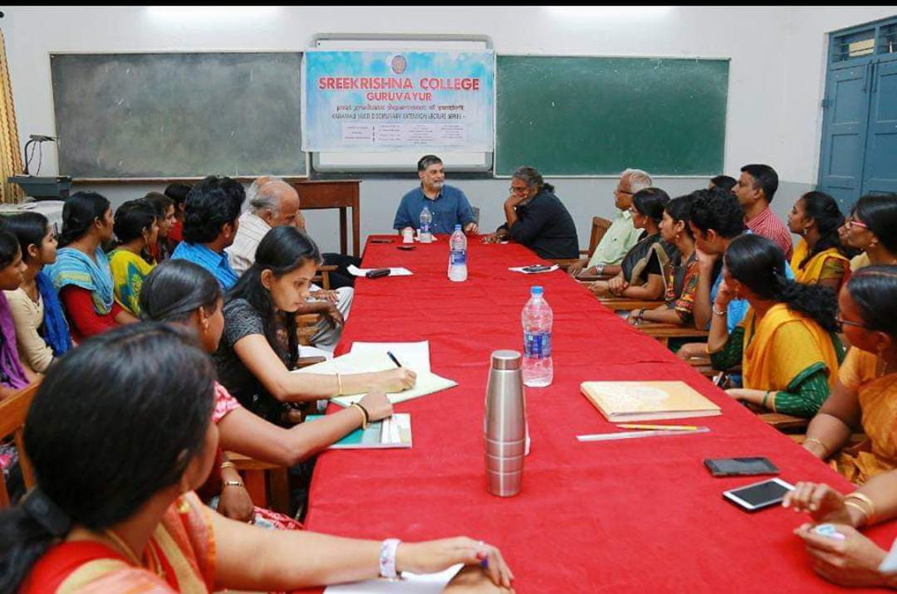

Lecture IX - 15/02/2018
Resource Person - Dr. K. Muthulakshmi , Professor and Head, Dept.of Vedhanta, SSUS, Rc,TVM
Dr. M.V. Natesan, Professor, Dept. of Vyakarana, SSUS, Kalady.
Prof. K.T. Madhavan, (Rtd.) Rashtriya Sanskrit Samsthan Deemed University, Puranattukara, Guruvayur
Topic - Advaitavedantic Methodology - Logical Perspectives
In Collabaration With SSUS Kalady and International School For Sree Sankara Studies (ISSS)
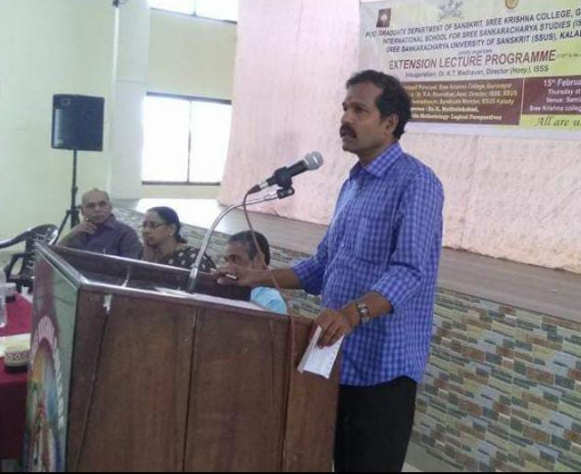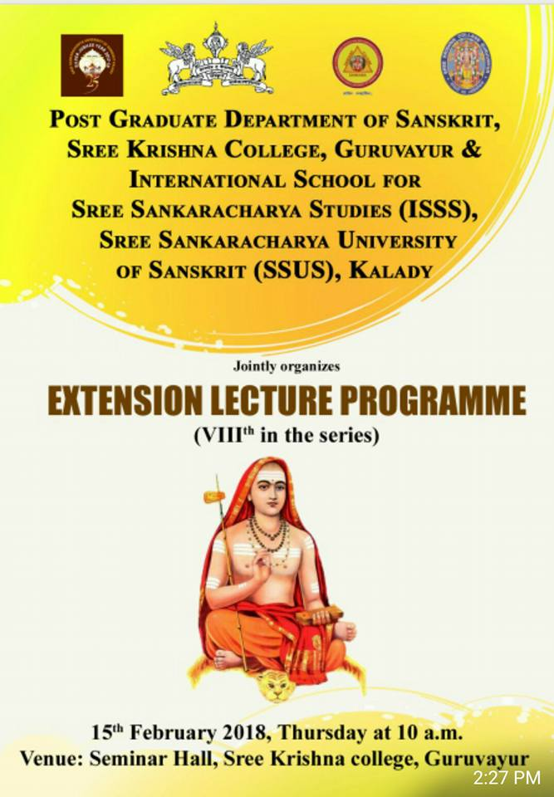
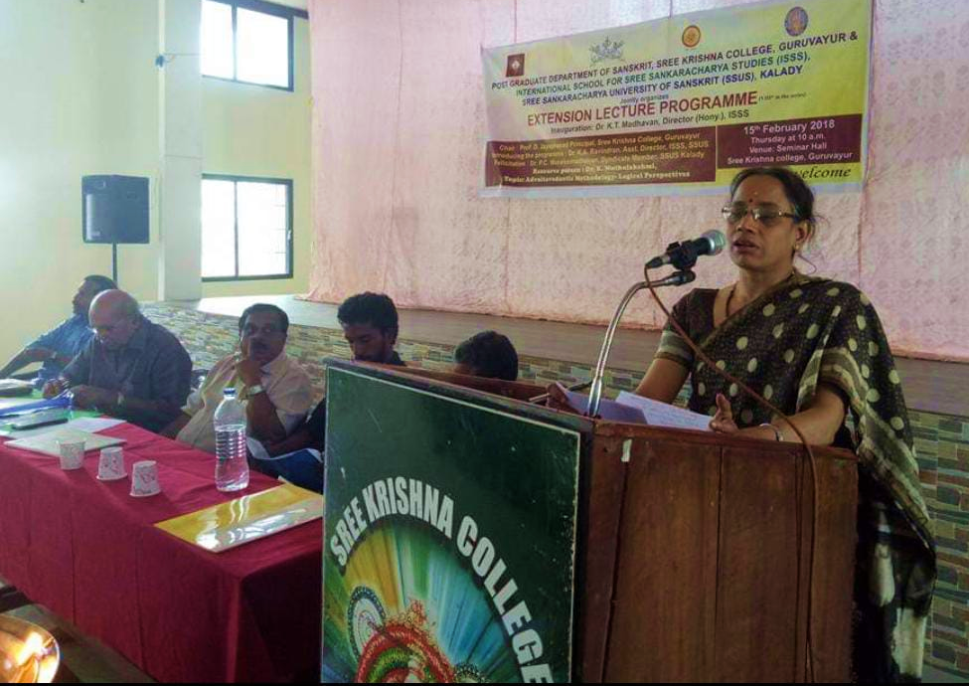

Lecture X - 09/03/2018
Resource Persons : (1)- Dr.Ettumanoor P Kannan , Directoer,Sangeethanadaka Acadamy, Koodiyattakendra.
(2) - Sri.M J Sreechithran,Art Critic
(3) -Guru Sri. Aravinda Pisharodi, Krishnanattam Maestro
Topic -Krishnattam and Natya Sasthra
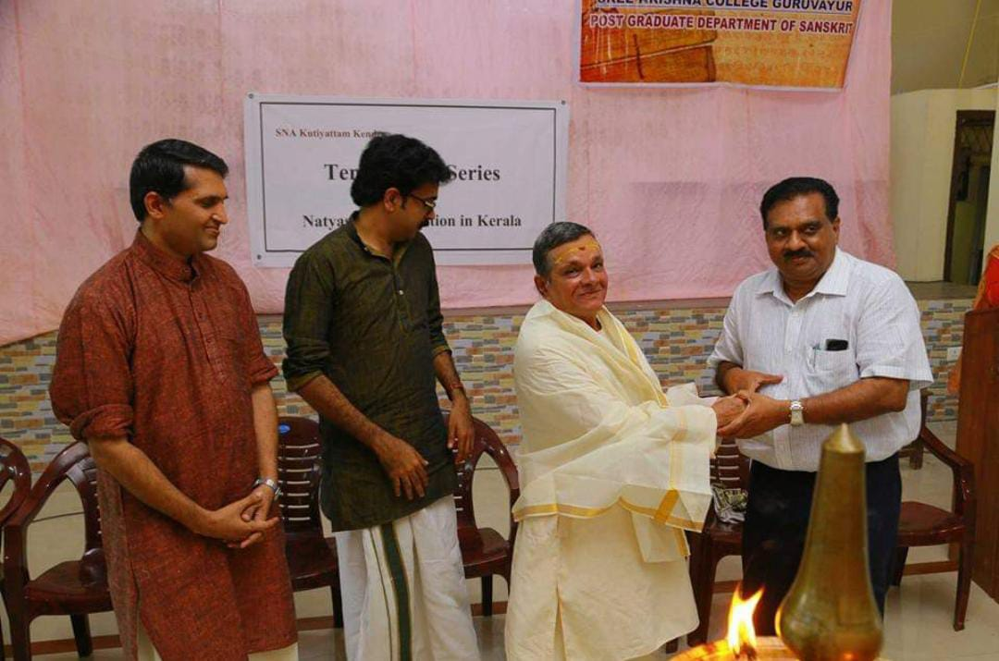
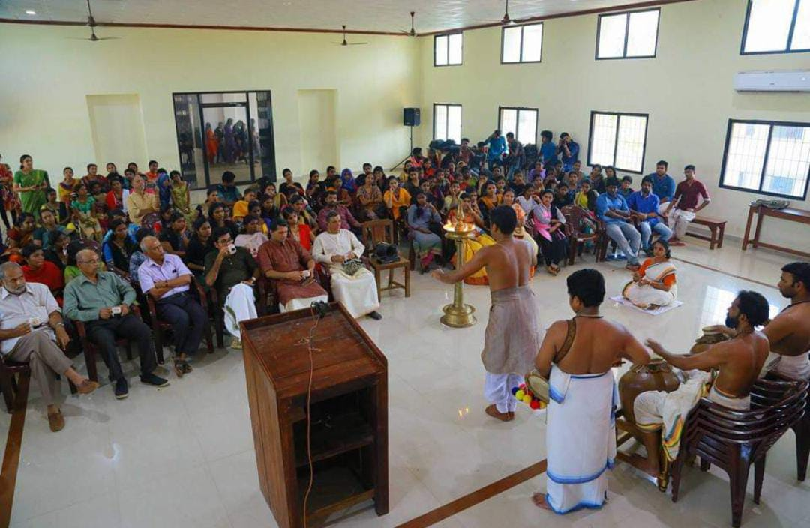

Lecture XI - 06/02/2019
Resource Persons - Guru Kalamandalam Girija and Smt.Usha Nangyar
Topic - Lecture Demonstraion on Theatare Techniques in Koodiyatta
In Collabaration With Sangeethanadaka Acadamy, Koodiyattakendra.
Lecture XII - 15/03/2019
Resource Person - Prof.K P. Babudas , Professor (Rtd) Department of Vedanta, Sree Sankara College, Kalady
Topic - Perpetual Significance of Advaitavedanta Philosophy
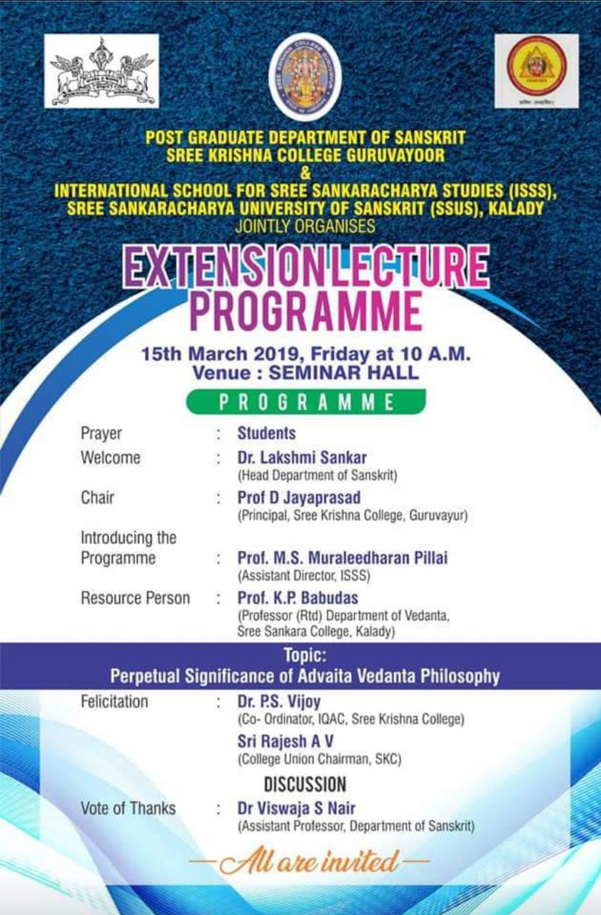
In Collabaration with SSUS Kalady and International School for Sree Sankara Studies (ISSS) 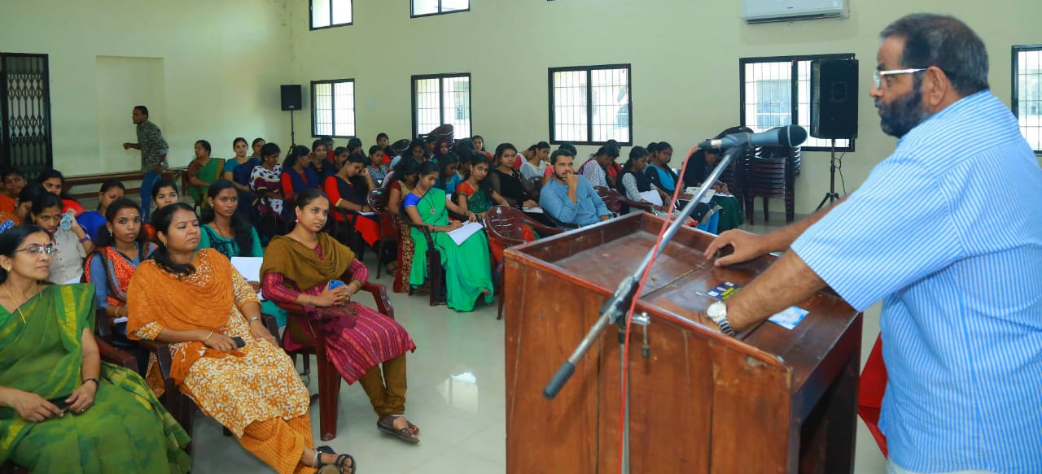

Lecture XIII - 02/04/2019
Resource Person - Dr.C Rajendran , Professor and Head Department of Sanskrit, University of Calicut
Topic -An Introduction to Western Literary Criticism
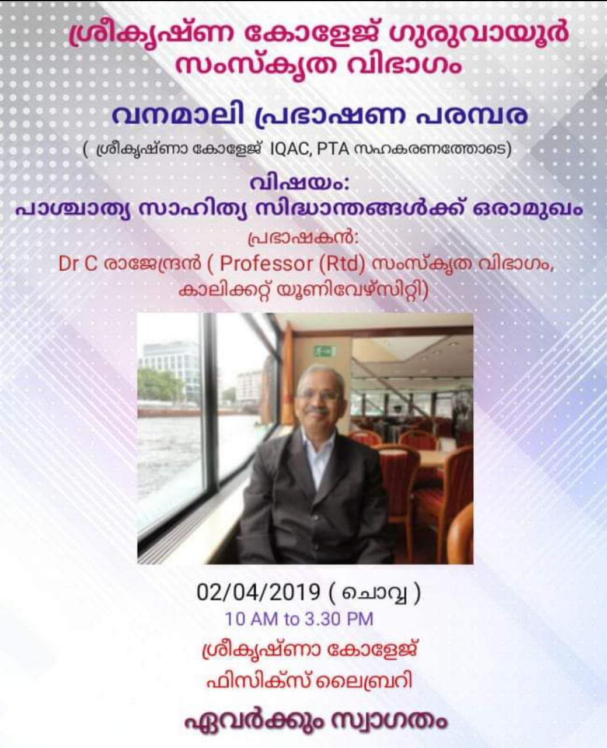

Lecture XIV - 26/02/2020
Resource Person - Dr. P.C. Muraleemadhavan, Professor and Head (Rtd) Department of Sanskrit Sahithya ,Sree Sankaracchaya University of Sanskrit Kalady
Topic -Literary Criticism through Ages
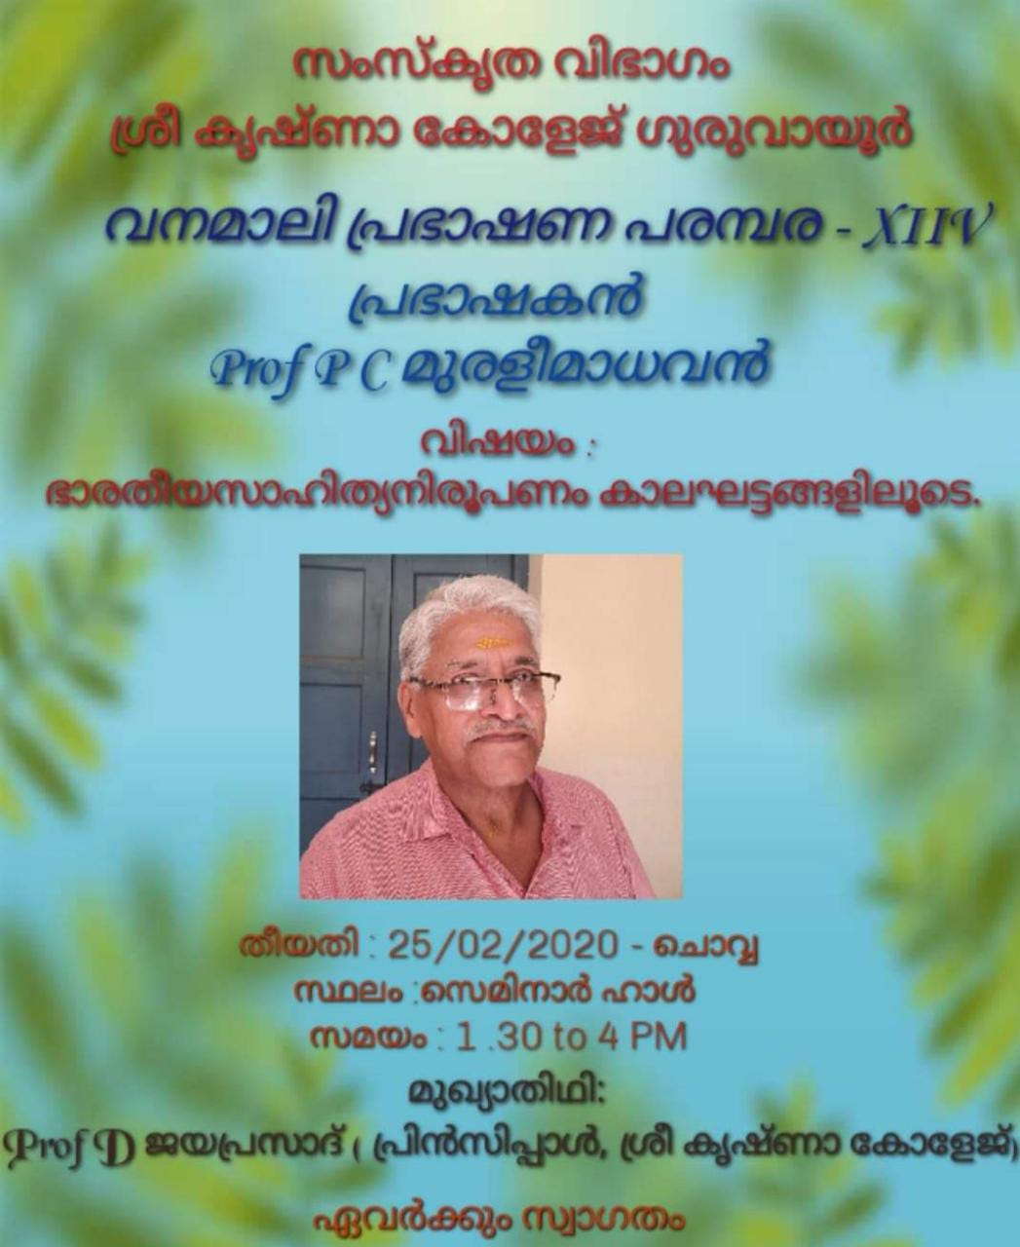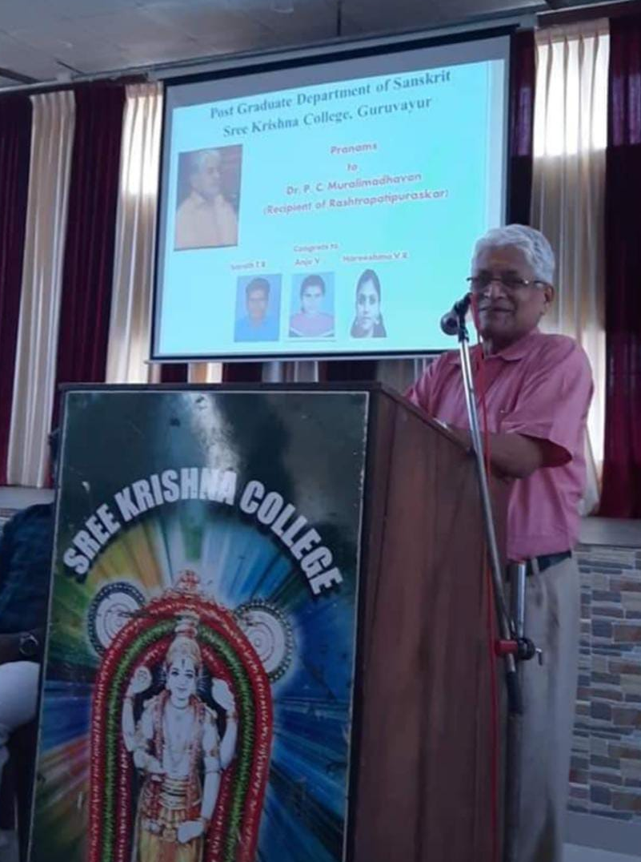
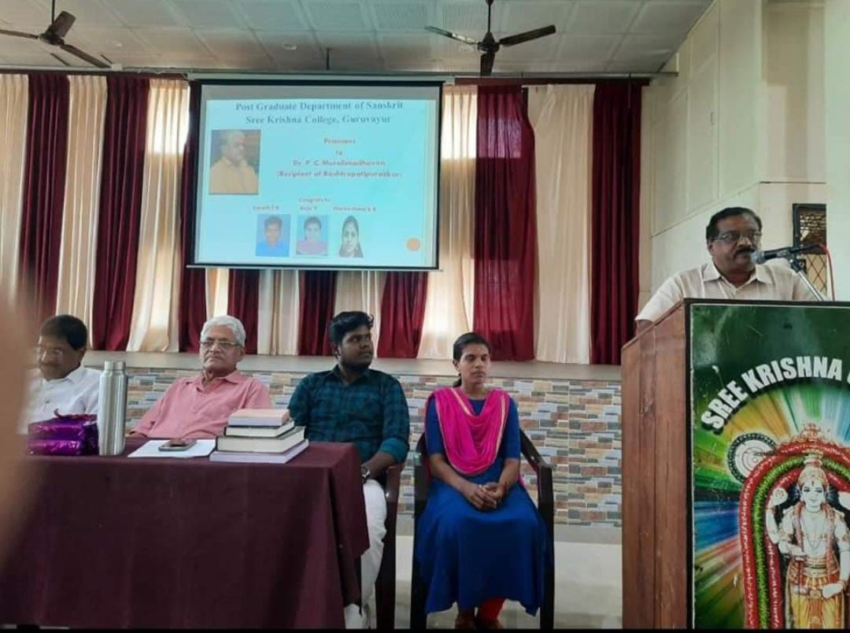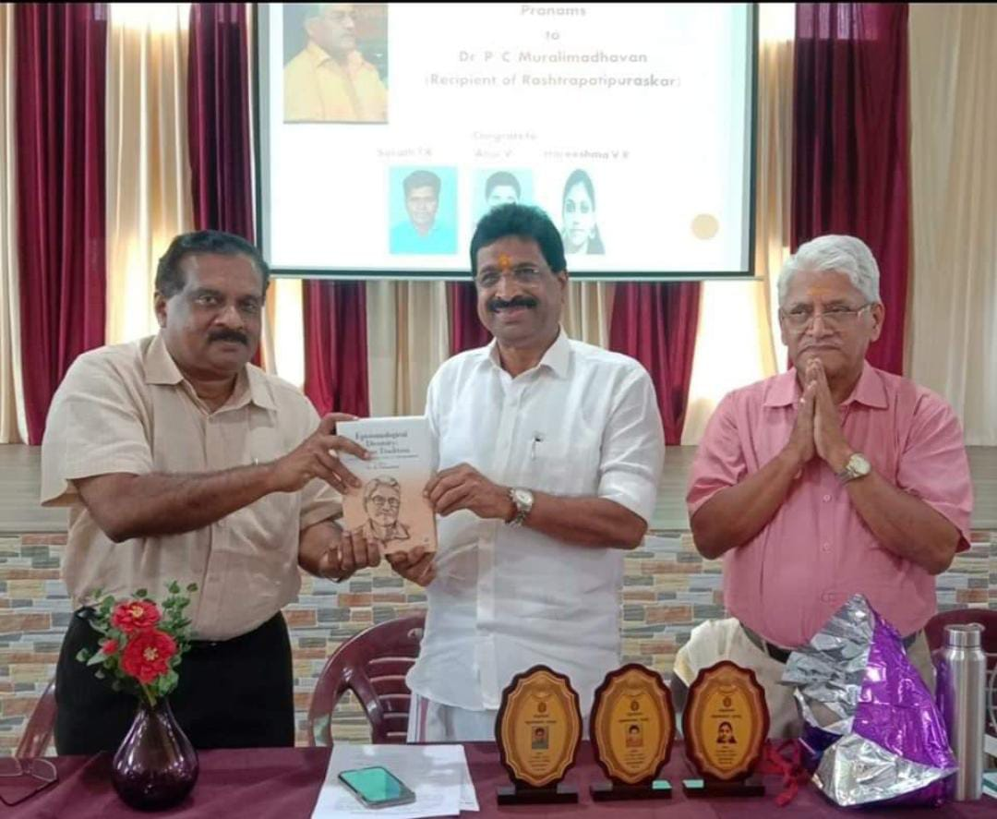

Lecture XV - 06/03/2019
Resource Person - Dr. N. K. Sundareswaran, Professor and Head Department Of Sanskrit, University of Calicut
Topic - Contribution of Kerala To Indian Mathametics
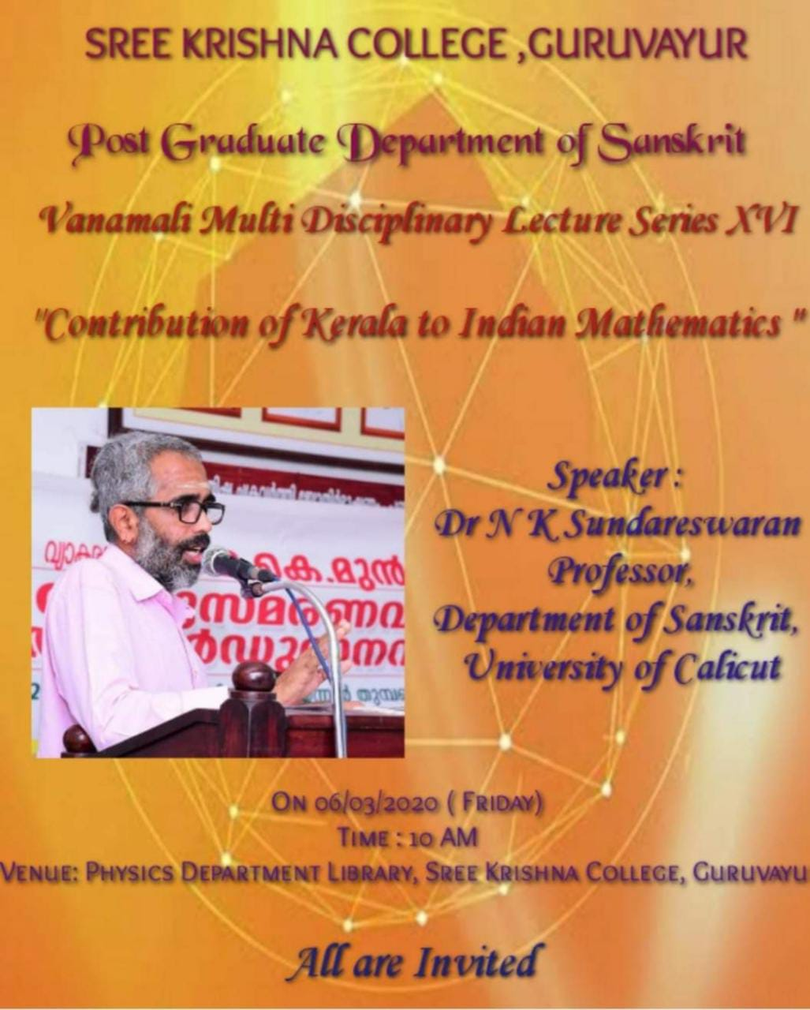

VANAMALI MULTI-DISCIPLINARY WEBINAR SERIES
WEBINAR I
Webinar on Sree Sankarajayanthi 2020
Date: 28/04/2020
Resource Persons: Dr.P. C Muraleemadhavan, Proffessor and Head (Rtd) Department of Sanskrit Sahithya, Sree Sankaracchaya University of Sanskrit Kalady
Dr. K. Muthulakshmi , Professor And Head, Dept. of Vedanta, Sree Sankaracchaya University of Sanskrit, Kalady
Dr. K. Harikrishna Sarma, Asst. Professor, Department of Sanskrit Vedanta, Sree Sankara College, Kalady
Topic: Contribution of Sree Sankaracharya to Indian Philosophical Thought
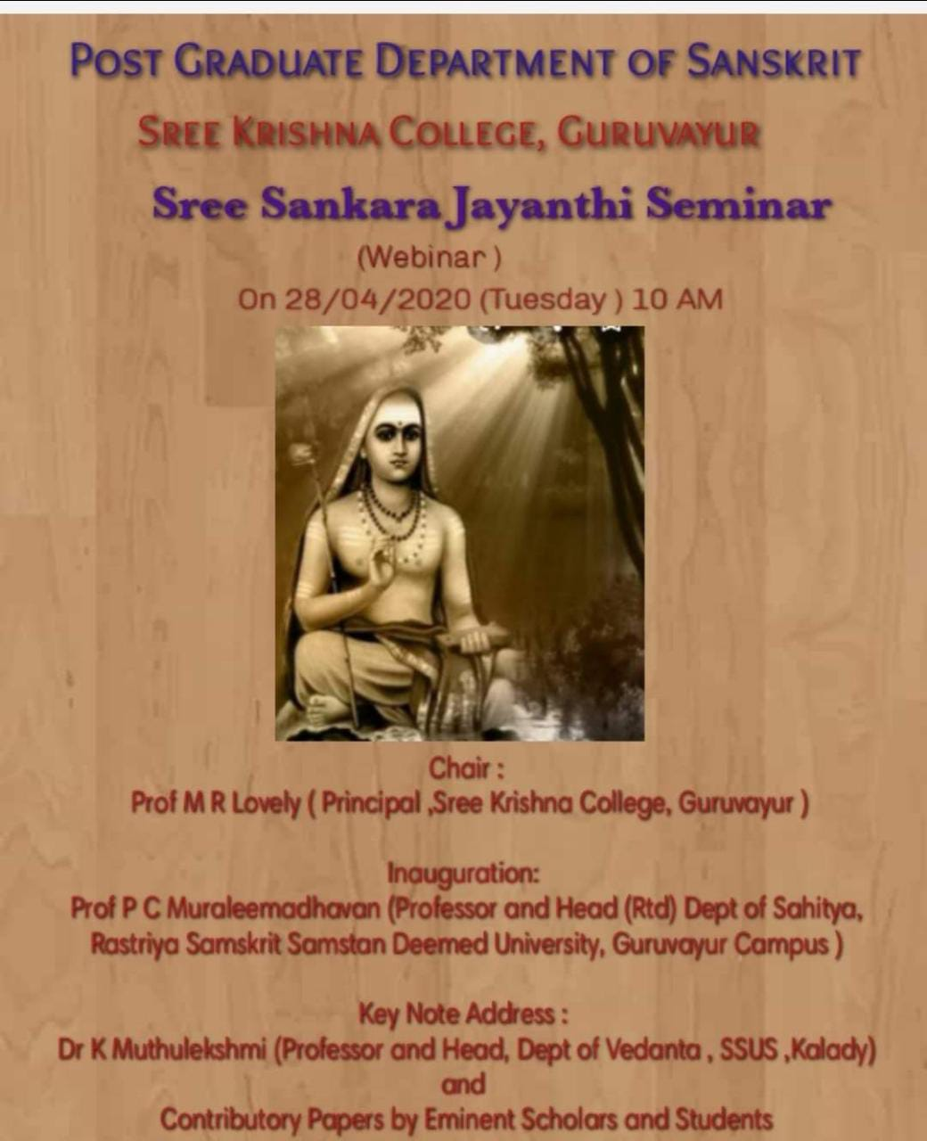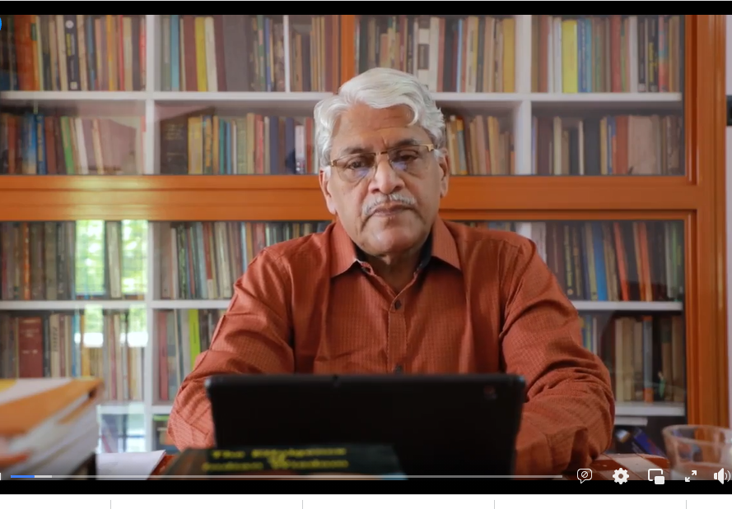

WEBINAR II
Date: 29/06/2020
Resource Person: Dr.Achyuth Sankar S. Nair, Prof. Of Computer Science, University Of Kerala
Topic: Education, Phiilosophy, Science and Technology
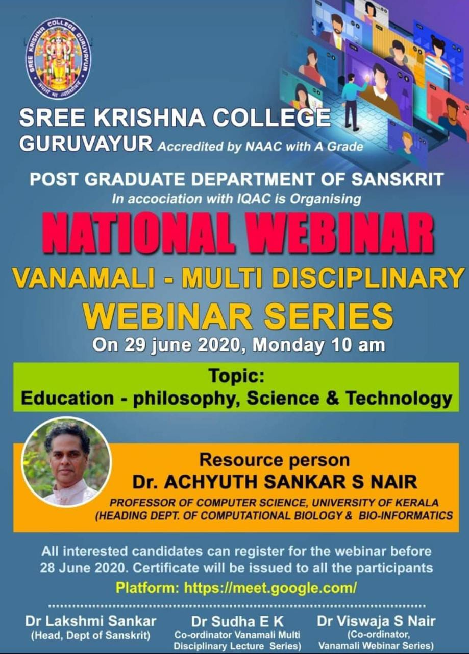

WEBINAR III
Date: 21/06/2020
Resource Person: (1) Dr.Ettumanoor P Kannan , Directoer,Sangeethanadaka Acadamy, Koodiyattakendra.
(2) Lt. Rajesh Madhavan, Asst. Professor, Dept. of Physical Education, Sree Krishna College, Guruvayur
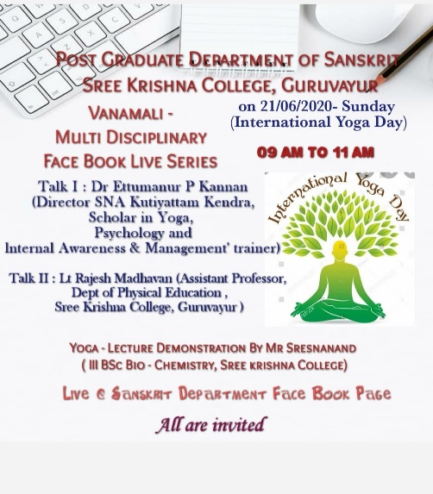
Topic : Yoga in Practical Life.

WEBINAR IV
Sanskrit day Celebration
Date: 03/07/2020
Resource Person: Dr.Jyotsna G.Asst.Prof. Department Of Sanskrit Vyakarana , Govt.Sanskrit College, Thripunithura
Topic: Possibilities of Sanskrit Studies In Modern Era
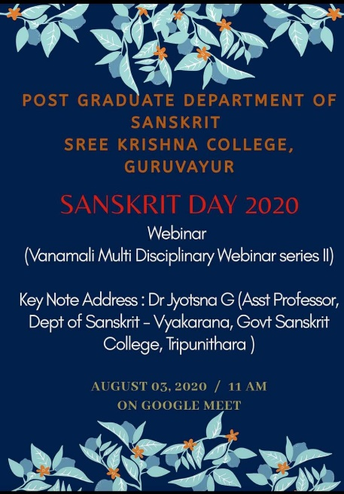

WEBINAR V
Date: 14/08/2020
Resource Person: Sri. Murali Puranattukara, Superinted, Krishnanattam Kalanilayam, Guruvayur Devaswom.
Topic : Ramayanam Aswadanathinte saadhyathakal.
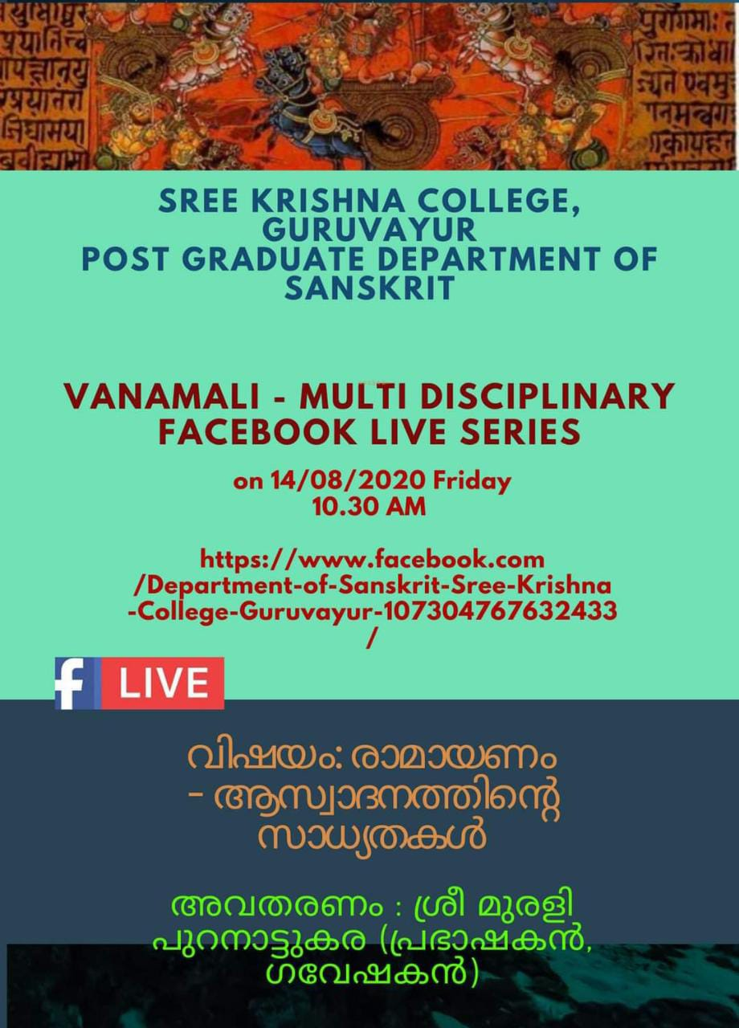

WEBINAR VI
NATIONAL WEBINAR ON INDIAN PHILOSOPHY
Date: 21/10/2020
Resource Person: Prof. E.Sreedharan, Professor (Rtd.), Department of Sahitya, Sree Sankaracharya University of Sanskrit, Kalady.
Topic : सांख्यदर्शनसमीक्षा
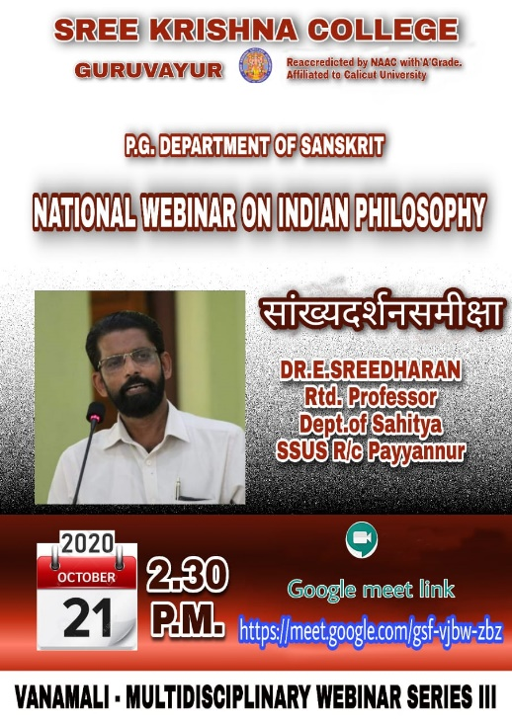

WEBINAR VII
NATIONAL WEBINAR ON INDIAN PHILOSOPHY
Date: 28/10/2020
Resource Person: Sri. Dhanesh P.V.
Topic: योगदर्शनसमीक्षा

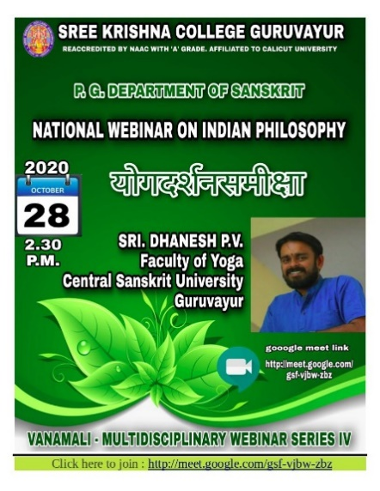

WEBINAR VIII
NATIONAL WEBINAR ON INDIAN PHILOSOPHY
Date: 29/01/2021
Resource Person: Dr. E. Devan
Topic: न्यायदर्शनसमीक्षा

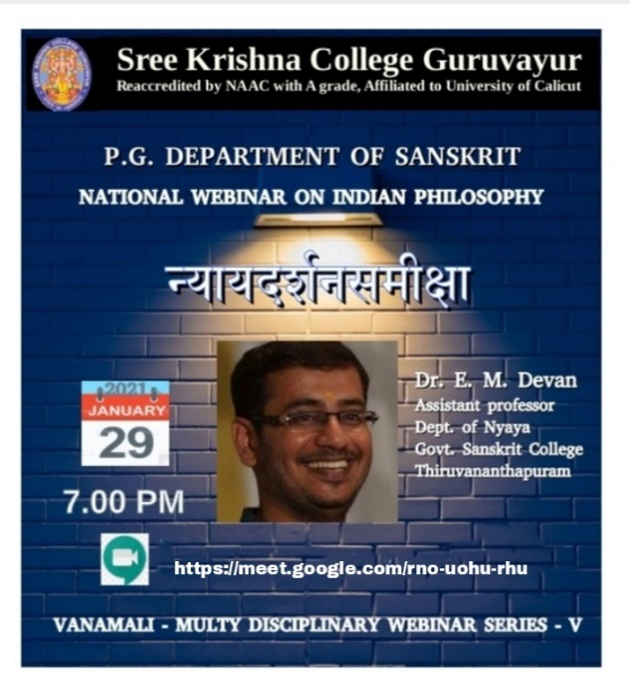

WEBINAR IX
NATIONAL WEBINAR ON INDIAN PHILOSOPHY
Date: 05/02/2021
Resource Person: Dr. K.M.Sangamesan, Associate
Topic: वैशेषिकदर्शनसमीक्षा
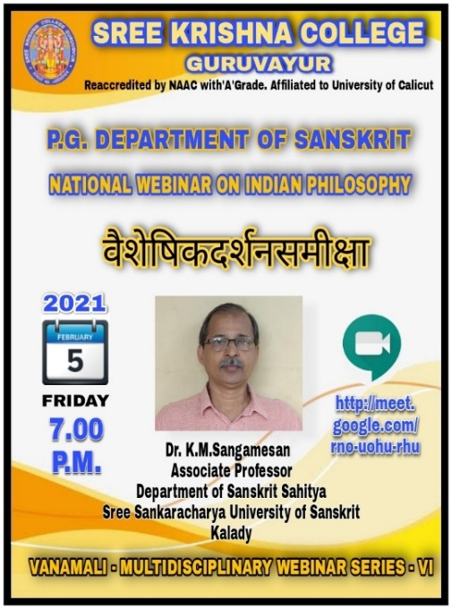

WEBINAR X
NATIONAL WEBINAR ON INDIAN PHILOSOPHY
Date: 19/02/2021
Resource Person: Dr. K.S.Maheswaran, Asst. Professor, Dept. of Advaithavedanta,
Topic: मीमांसादर्शनसमीक्षा

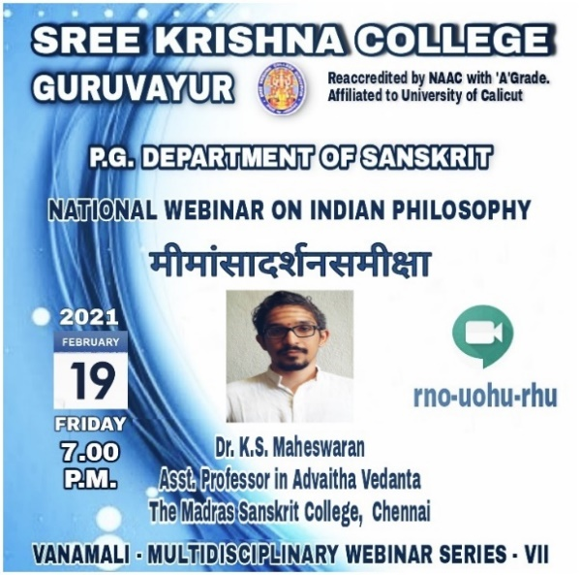

WEBINAR XI
NATIONAL WEBINAR ON INDIAN PHILOSOPHY
Date: 26/02/2021
Resource Person: Sri. K. Karthik Sharma, Asst. Professor, Dept.
Topic वेदान्तदर्शनसमीक्षा
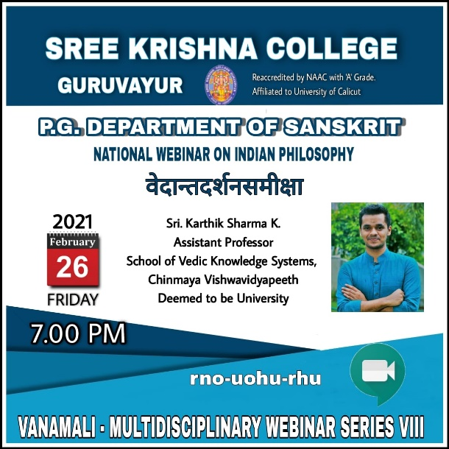

WEBINAR XII
Sanskrit Day Celebration 2021
Date: 13/08/2021
Resource Person: Dr. P.V.Viswanathan Namboothiri, Professor Rtd., Basalious College, Kottayam
Topic: संस्कृतदिनसन्देशः।

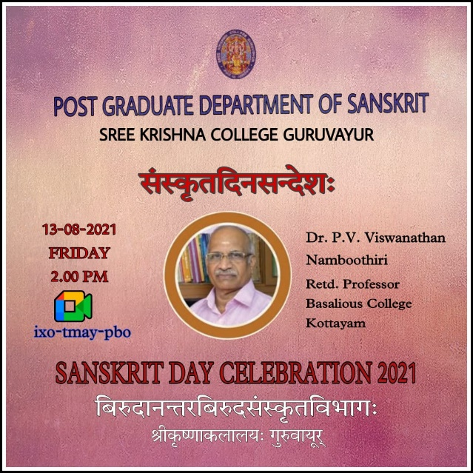

LECTURE DEMONSTRATION of KOODIYATTAM
SUBHADRADHANANJAYAM
Date: 11/03/019
In collaboration with Sangeethanataka Academy Koodiyattakendra
Lecture Demonstration by Ammannur Chachchu Chakyar Smaraka Gurukulam, Iringalakuda

